SIMATS ENGINEERING (SAVEETHA SCHOOL OF ENGINEERING)
Department of Computer Science and Engineering

ASSESSMENT TOOL 2 – EXPERIMENTATION

Course Code: | ITA0301 | Course Title: | Mobile computing
CO Assessed: | CO2 | Assessment: | Assessment Tool 2 – EXPERIMENTATION
Weightage: | 30 % of CIA | Total Marks: | 100 marks
CO2 Statement: | Compare mobile communication technologies, including multiple access techniques and network evolution, based on performance and applications.
Student Name: | Ch.Ishwarya | Reg. No.: | 192324145
Section / Batch: | AI&DS | Date: | 21-10-2026

Code of Conduct

I Ch.Ishwarya (192324145) (Name / Reg. No) certify that this submission is my original work and that I have adhered to the guidelines specified for this assessment. I understand that any violation of academic integrity rules will result in disciplinary action.
Signature of the Student: 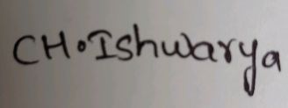_
Instructions
- This test contains FIVE questions.
- Duration: 60 minutes (homework)

Faculty In-charge | Course Coordinator | Head of Department
Signature: _______________ | Signature: _______________ | Signature: _______________
Date: ___________________ | Date: ___________________ | Date: ___________________

Annexure A - QUESTIONS

1. Figma-Based Mobile IP Communication Workflow Analysis (BL4 – Analyze)
Design an interactive Figma prototype illustrating the complete workflow of Mobile IP communication when a Mobile Node moves from its Home Network to a Foreign Network. Your design should include the Home Agent (HA), Foreign Agent (FA), Correspondent Node (CN), Careof Address (CoA), Registration Process, and Packet Tunneling. Analyze the communication process by identifying:
- The purpose of each network component.
- Points where packet delay or packet loss may occur.
- The effect of node mobility on communication performance. ● Possible improvements to reduce latency.
Deliverables:
- Figma (.fig) design
- GitHub repository containing exported images/PDF and documentation (README).

AIM : To design an interactive Figma prototype showing Mobile IP communication when a Mobile Node (MN) moves from its Home Network to a Foreign Network, and to analyze the role of each component, the points of delay or packet loss, the effect of mobility on performance, and possible latency improvements.

PROCEDURE:
- open Figma
- Create a new file
- Select the Frames
- Fill in the content that is required for presentation
- Design Visual Elements
- Make it Interactive
- Add Annotations and Explanations
- Incorporate Multimedia
- Storyboard Animation
- Review and edit the Prototype
- Save and Share

DESIGN :
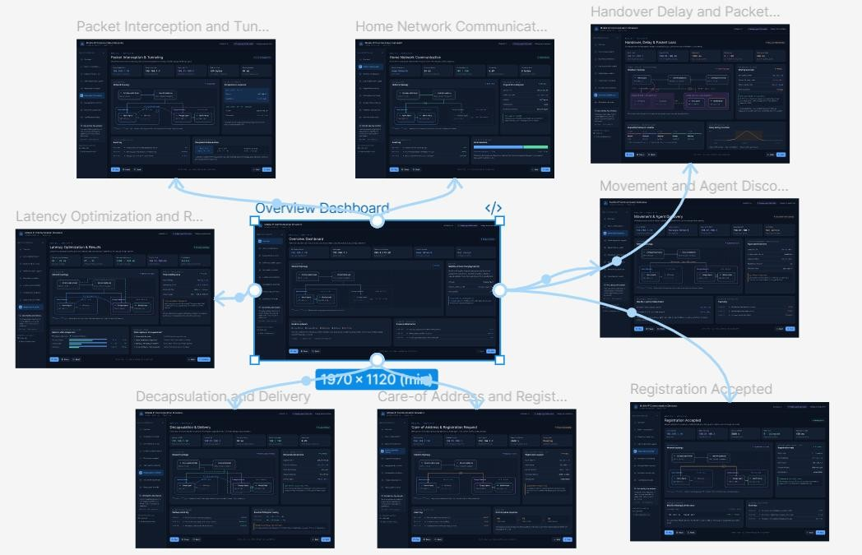

2. Comparative Network Architecture Design Using Figma (BL4 – Analyze)
Using Figma or draw.io, create a comparative architectural diagram showing both a Cellular Wireless Network and a Mobile Ad Hoc Network (MANET) operating in the same smart city environment. Analyze the architectures by comparing:
- Infrastructure dependency.
- Routing mechanisms.
- Scalability.
- Fault tolerance.
- Mobility support.
- Suitable application scenarios.
Highlight the advantages and limitations of each architecture through annotations in your design. Deliverables:
- Editable design file.
- GitHub repository with screenshots, comparison report, and design assets.

AIM : To create a comparative architectural diagram of a Cellular Wireless Network and a Mobile Ad Hoc Network (MANET) operating in the same smart city environment, and to analyze them in terms of
infrastructure dependency, routing, scalability, fault tolerance, mobility support, and suitable applications, with advantages and limitations annotated in the design.

PROCEDURE:
- open Figma
- Create a new file
- Select the Frames
- Fill in the content that is required for presentation
- Design Visual Elements
- Make it Interactive
- Add Annotations and Explanations
- Incorporate Multimedia
- Storyboard Animation
- Review and edit the Prototype
- Save and Share

DESIGN:
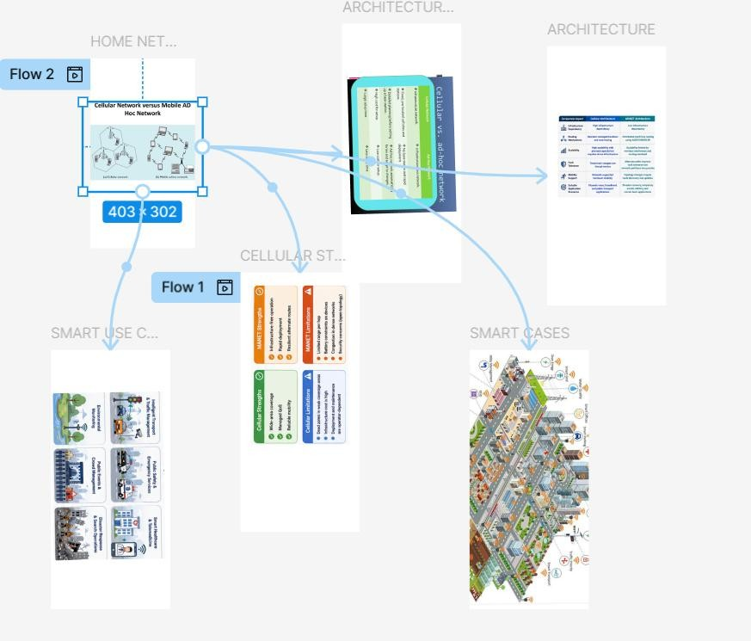

3. Routing Protocol Visualization and Analysis (BL4 – Analyze)
Develop an interactive visualization using Figma, Mermaid.js, D3.js, or any visualization framework illustrating the operation of one Proactive Routing Protocol and one Reactive Routing Protocol in a mobile wireless network.
Analyze:
- Route discovery process.
- Route maintenance mechanism.
- Routing overhead.
- Delay in establishing communication.
- Performance under high node mobility.
Include a comparative summary explaining which protocol performs better under different mobility conditions.
Deliverables:
- Source code/design files.
- GitHub repository with implementation, screenshots, and analysis report.

AIM : To visualize and analyze the working of one proactive routing protocol (OLSR) and one reactive routing protocol (AODV) in a mobile wireless network, comparing route discovery, route maintenance, routing overhead, communication delay, and performance under high node mobility.

PROCEDURE :
- open Figma
- Create a new file
- Select the Frames
- Fill in the content that is required for presentation
- Design Visual Elements
- Make it Interactive
- Add Annotations and Explanations
- Incorporate Multimedia
- Storyboard Animation
- Review and edit the Prototype
- Save and Share

DESIGN:
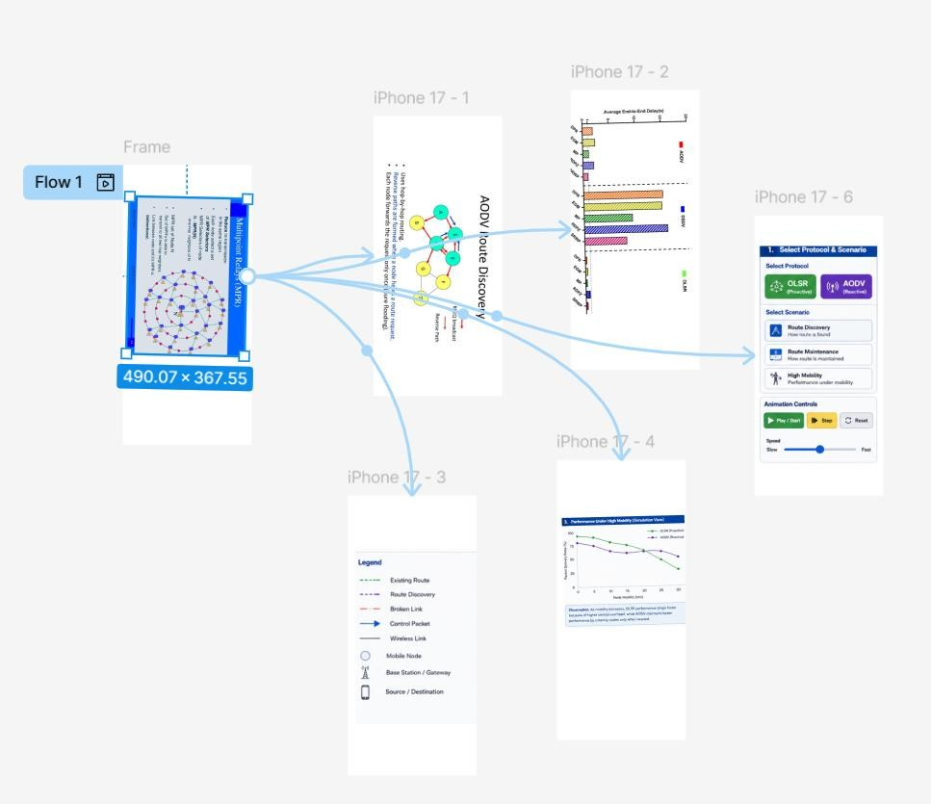

4. Mobile IP Application Design for Smart Healthcare (BL4 – Analyze)
Design a Smart Healthcare Mobile IP system using Figma that enables doctors, ambulances, hospitals, and patients to remain connected while moving across different wireless networks.
Analyze:
- How Mobile IP maintains uninterrupted communication.
- Challenges during handoff between networks.
- Security vulnerabilities during mobility.
- Possible design improvements to increase reliability.
Provide navigation between screens demonstrating different mobility scenarios.
Deliverables:
- Interactive prototype.
- GitHub repository containing design files, exported prototype, and documentation. 5.
Wireless Network Decision Dashboard Using GitHub Project (BL4 – Analyze)

AIM :
Create a web-based dashboard (using HTML/CSS/JavaScript, React, or another programming framework) or an interactive Figma dashboard that helps network engineers determine whether a given scenario should use Mobile IP, Cellular Networks, or Ad Hoc Networks.

PROCEDURE:

- open Figma
- Create a new file
- Select the Frames
- Fill in the content that is required for presentation
- Design Visual Elements
- Make it Interactive
- Add Annotations and Explanations
- Incorporate Multimedia
- Storyboard Animation
- Review and edit the Prototype
- Save and Share

DESIGN :
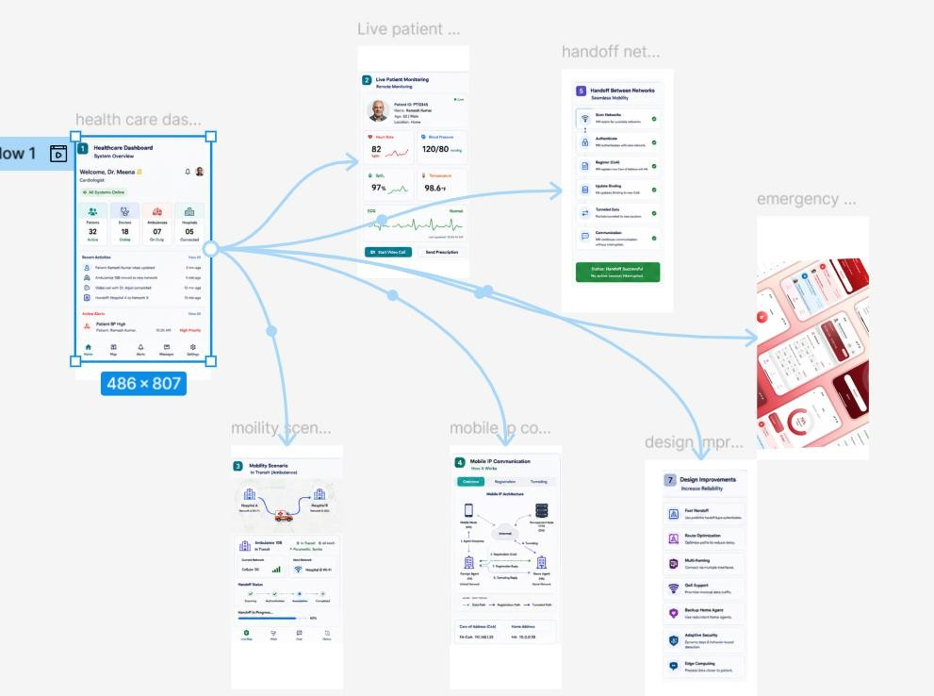
5. Wireless Network Decision Dashboard Using GitHub Project (BL4 – Analyze)
Create a web-based dashboard (using HTML/CSS/JavaScript, React, or another programming framework) or an interactive Figma dashboard that helps network engineers determine whether a given scenario should use Mobile IP, Cellular Networks, or Ad Hoc Networks.

The dashboard should analyze multiple parameters such as:
  - Node mobility.
  - Infrastructure availability.
  - Network size.
  - Routing complexity.
  - Energy consumption.
  - Reliability requirements.
The system should justify its recommendation based on the analyzed parameters.
Deliverables:
  - Source code or Figma project.
  - GitHub repository with complete code/design, README, screenshots, and analysis report.

AIM: To design an interactive Wireless Network Decision Dashboard using HTML, CSS, JavaScript, or
Figma that helps network engineers select the most suitable technology — Mobile IP, Cellular
Networks, or Ad Hoc Networks — by analyzing node mobility, infrastructure availability, network size, routing complexity, energy consumption, and reliability requirements, and providing a justified recommendation for each scenario.

PROCEDURE:
- open Figma
- Create a new file
- Select the Frames
- Fill in the content that is required for presentation
- Design Visual Elements
- Make it Interactive
- Add Annotations and Explanations
- Incorporate Multimedia
- Storyboard Animation
- Review and edit the Prototype
- Save and Share

DESIGN:
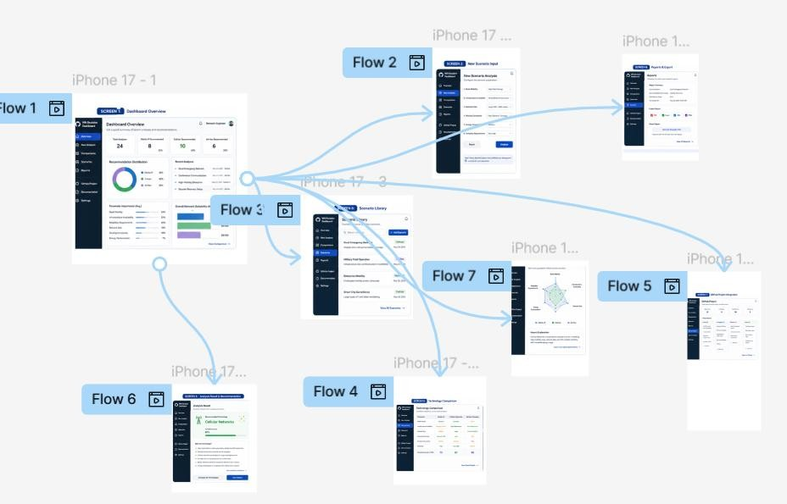

Criterion | Marks
Design Quality (Figma/Programming Tool) | 20
Technical Analysis | 30
Correctness of Mobile Networking Concepts | 20
GitHub Repository Organization & Documentation | 15
Creativity and Visualization | 15
Total | 100 Marks

